There is a ball in a maze with empty spaces (represented as 0) and walls (represented as 1). The ball can go through the empty spaces by rolling **up, down, left or right**, but it won't stop rolling until hitting a wall. When the ball stops, it could choose the next direction. There is also a hole in this maze. The ball will drop into the hole if it rolls onto the hole.

Given the m x n maze, the ball's position ball and the hole's position hole, where ball = [ballrow, ballcol] and hole = [holerow, holecol], return *a string*instructions*of all the instructions that the ball should follow to drop in the hole with the****shortest distance****possible*. If there are multiple valid instructions, return the **lexicographically minimum** one. If the ball can't drop in the hole, return "impossible".

If there is a way for the ball to drop in the hole, the answer instructions should contain the characters 'u' (i.e., up), 'd' (i.e., down), 'l' (i.e., left), and 'r' (i.e., right).

The **distance** is the number of **empty spaces** traveled by the ball from the start position (excluded) to the destination (included).

You may assume that **the borders of the maze are all walls** (see examples).

**Example 1:**

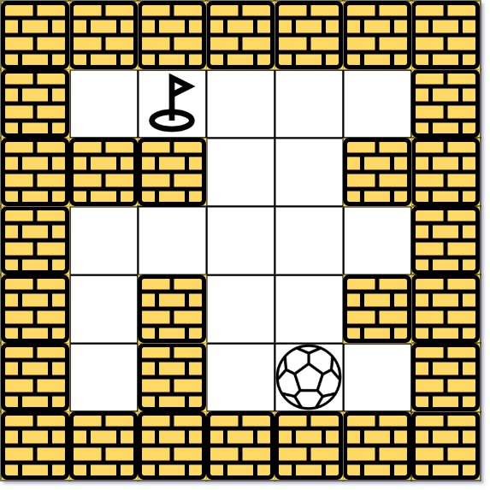

**Input:** maze = [[0,0,0,0,0],[1,1,0,0,1],[0,0,0,0,0],[0,1,0,0,1],[0,1,0,0,0]], ball = [4,3], hole = [0,1]

**Output:** "lul"

**Explanation:** There are two shortest ways for the ball to drop into the hole.

The first way is left -> up -> left, represented by "lul".

The second way is up -> left, represented by 'ul'.

Both ways have shortest distance 6, but the first way is lexicographically smaller because 'l' < 'u'. So the output is "lul".

**Example 2:**

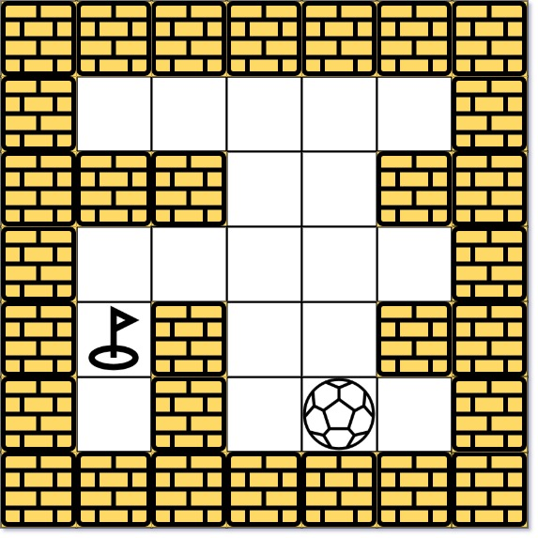

**Input:** maze = [[0,0,0,0,0],[1,1,0,0,1],[0,0,0,0,0],[0,1,0,0,1],[0,1,0,0,0]], ball = [4,3], hole = [3,0]

**Output:** "impossible"

**Explanation:** The ball cannot reach the hole.

**Example 3:**

**Input:** maze = [[0,0,0,0,0,0,0],[0,0,1,0,0,1,0],[0,0,0,0,1,0,0],[0,0,0,0,0,0,1]], ball = [0,4], hole = [3,5]

**Output:** "dldr"

**Constraints:**

* m == maze.length
* n == maze[i].length
* 1 <= m, n <= 100
* maze[i][j] is 0 or 1.
* ball.length == 2
* hole.length == 2
* 0 <= ballrow, holerow <= m
* 0 <= ballcol, holecol <= n
* Both the ball and the hole exist in an empty space, and they will not be in the same position initially.
* The maze contains **at least 2 empty spaces**.